**Microservices with API gateway**

Creating Microservices for account and loan

**1. account Microservice**

**AccountApplication.java**

package com.cognizant.account;

import org.springframework.boot.SpringApplication;

import org.springframework.boot.autoconfigure.SpringBootApplication;

@SpringBootApplication

public class AccountApplication {

public static void main(String[] args) {

SpringApplication.run(AccountApplication.class, args);

}

}

**AccountController.java**

package com.cognizant.account;

import org.springframework.web.bind.annotation.*;

@RestController

@RequestMapping("/accounts")

public class AccountController {

@GetMapping("/{number}")

public Account getAccount(@PathVariable String number) {

return new Account(number, "savings", 234343);

}

static class Account {

public String number;

public String type;

public double balance;

public Account(String number, String type, double balance) {

this.number = number;

this.type = type;

this.balance = balance;

}

}

}

**application.properties**

server.port=8080

spring.application.name=account-service

**pom.xml**

<project xmlns="http://maven.apache.org/POM/4.0.0"

xmlns:xsi="http://www.w3.org/2001/XMLSchema-instance"

xsi:schemaLocation="http://maven.apache.org/POM/4.0.0

https://maven.apache.org/xsd/maven-4.0.0.xsd">

<modelVersion>4.0.0</modelVersion>

<groupId>com.cognizant</groupId>

<artifactId>account</artifactId>

<version>0.0.1-SNAPSHOT</version>

<name>account</name>

<description>Account Microservice</description>

<properties>

<java.version>17</java.version>

</properties>

<dependencies>

<dependency>

<groupId>org.springframework.boot</groupId>

<artifactId>spring-boot-starter-web</artifactId>

</dependency>

<dependency>

<groupId>org.springframework.boot</groupId>

<artifactId>spring-boot-devtools</artifactId>

<scope>runtime</scope>

</dependency>

<dependency>

<groupId>org.springframework.boot</groupId>

<artifactId>spring-boot-starter-test</artifactId>

<scope>test</scope>

</dependency>

</dependencies>

<build>

<plugins>

<plugin>

<groupId>org.springframework.boot</groupId>

<artifactId>spring-boot-maven-plugin</artifactId>

</plugin>

</plugins>

</build>

</project>

**2. loan Microservice**

**LoanApplication.java**

package com.cognizant.loan;

import org.springframework.boot.SpringApplication;

import org.springframework.boot.autoconfigure.SpringBootApplication;

@SpringBootApplication

public class LoanApplication {

public static void main(String[] args) {

SpringApplication.run(LoanApplication.class, args);

}

}

**LoanController.java**

package com.cognizant.loan;

import org.springframework.web.bind.annotation.*;

@RestController

@RequestMapping("/loans")

public class LoanController {

@GetMapping("/{number}")

public Loan getLoan(@PathVariable String number) {

return new Loan(number, "car", 400000, 3258, 18);

}

static class Loan {

public String number;

public String type;

public double loan;

public double emi;

public int tenure;

public Loan(String number, String type, double loan, double emi, int tenure) {

this.number = number;

this.type = type;

this.loan = loan;

this.emi = emi;

this.tenure = tenure;

}

}

}

**application.properties**

server.port=8081

spring.application.name=loan-service

**pom.xml**

<project xmlns="http://maven.apache.org/POM/4.0.0"

xmlns:xsi="http://www.w3.org/2001/XMLSchema-instance"

xsi:schemaLocation="http://maven.apache.org/POM/4.0.0

https://maven.apache.org/xsd/maven-4.0.0.xsd">

<modelVersion>4.0.0</modelVersion>

<groupId>com.cognizant</groupId>

<artifactId>loan</artifactId>

<version>0.0.1-SNAPSHOT</version>

<name>loan</name>

<description>Loan Microservice</description>

<properties>

<java.version>17</java.version>

</properties>

<dependencies>

<dependency>

<groupId>org.springframework.boot</groupId>

<artifactId>spring-boot-starter-web</artifactId>

</dependency>

<dependency>

<groupId>org.springframework.boot</groupId>

<artifactId>spring-boot-devtools</artifactId>

<scope>runtime</scope>

</dependency>

<dependency>

<groupId>org.springframework.boot</groupId>

<artifactId>spring-boot-starter-test</artifactId>

<scope>test</scope>

</dependency>

</dependencies>

<build>

<plugins>

<plugin>

<groupId>org.springframework.boot</groupId>

<artifactId>spring-boot-maven-plugin</artifactId>

</plugin>

</plugins>

</build>

</project>

**Output:**

**Account**

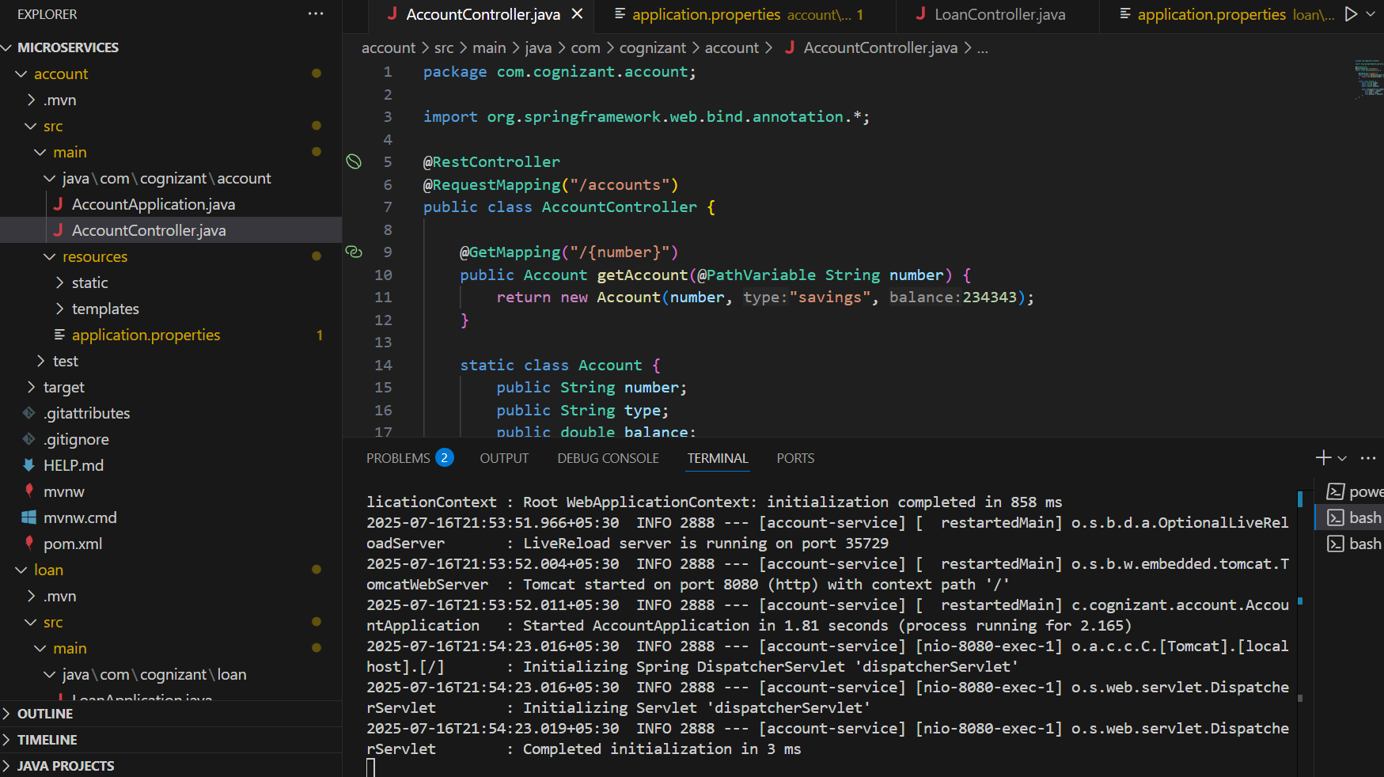

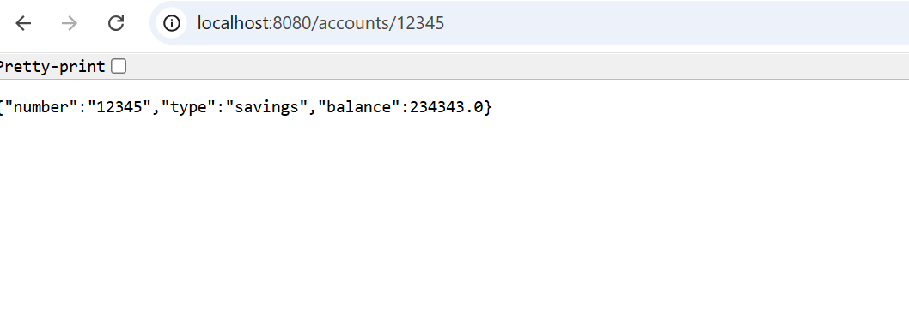

**Loan**

